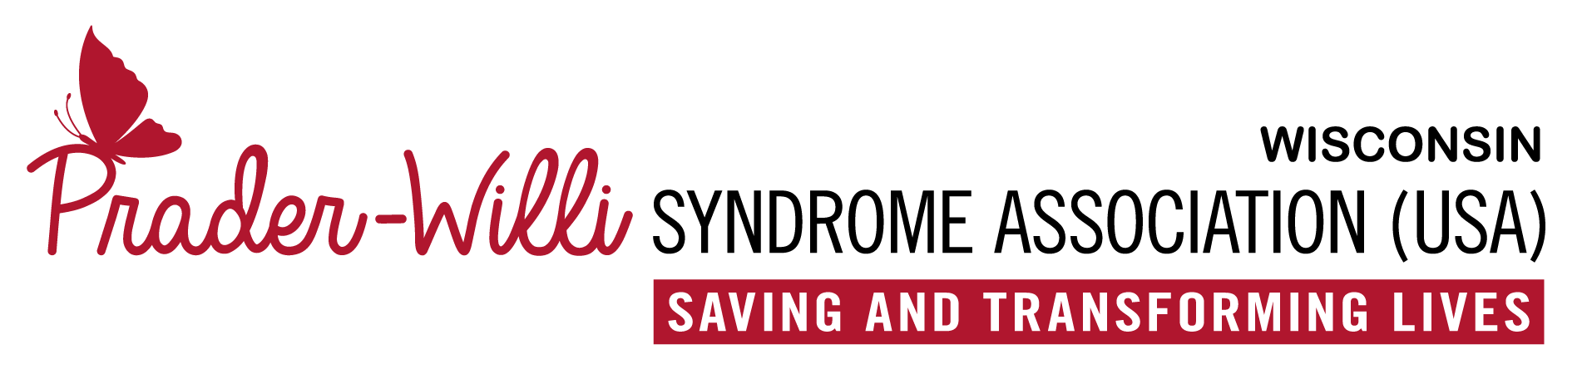

Parent Release Form for Media Recording
I, the undersigned, do hereby grant or deny permission to the Prader-Willi Syndrome Association of Wisconsin, Inc. to use the image of my child, _________________________________, as marked by my selection(s) below. Such use includes the display, distribution, publication, transmission, or otherwise use of photographs, images, and/or video taken of my child for use in materials that include, but may not be limited to, printed materials such as brochures and newsletters, videos, and digital images such as those on the Prader-Willi Syndrome Association of Wisconsin, Inc. website or the Facebook page.
☐ | Deny permission to use my child’s image at all.
☐ | Grant permission to use my child’s image in the following ways (mark all that apply):
☐ | Limited usage: I want my child’s image used on printed materials only (no digital or video use)
☐ | Unrestricted usage: I give unrestricted permission for my child’s image to be used in print, video, and digital media. I agree that these may be used by the Prader-Willi Syndrome Association of Wisconsin, Inc. for a variety of purposes and that these images may be used without further notifying me. I do understand that the child’s last name will not be used in conjunction with any video or digital images.

**This consent to share information is good for 10 years from the date of signature unless revoked in writing.**

Parent/Guardian signature |  |  | Date

Please make a copy of this form for your own records and mail or email the original to:
Prader-Willi Syndrome Association of Wisconsin, Inc.
PO Box 226
Oconomowoc, WI 53066
ProgDir@pwsaofwi.org

